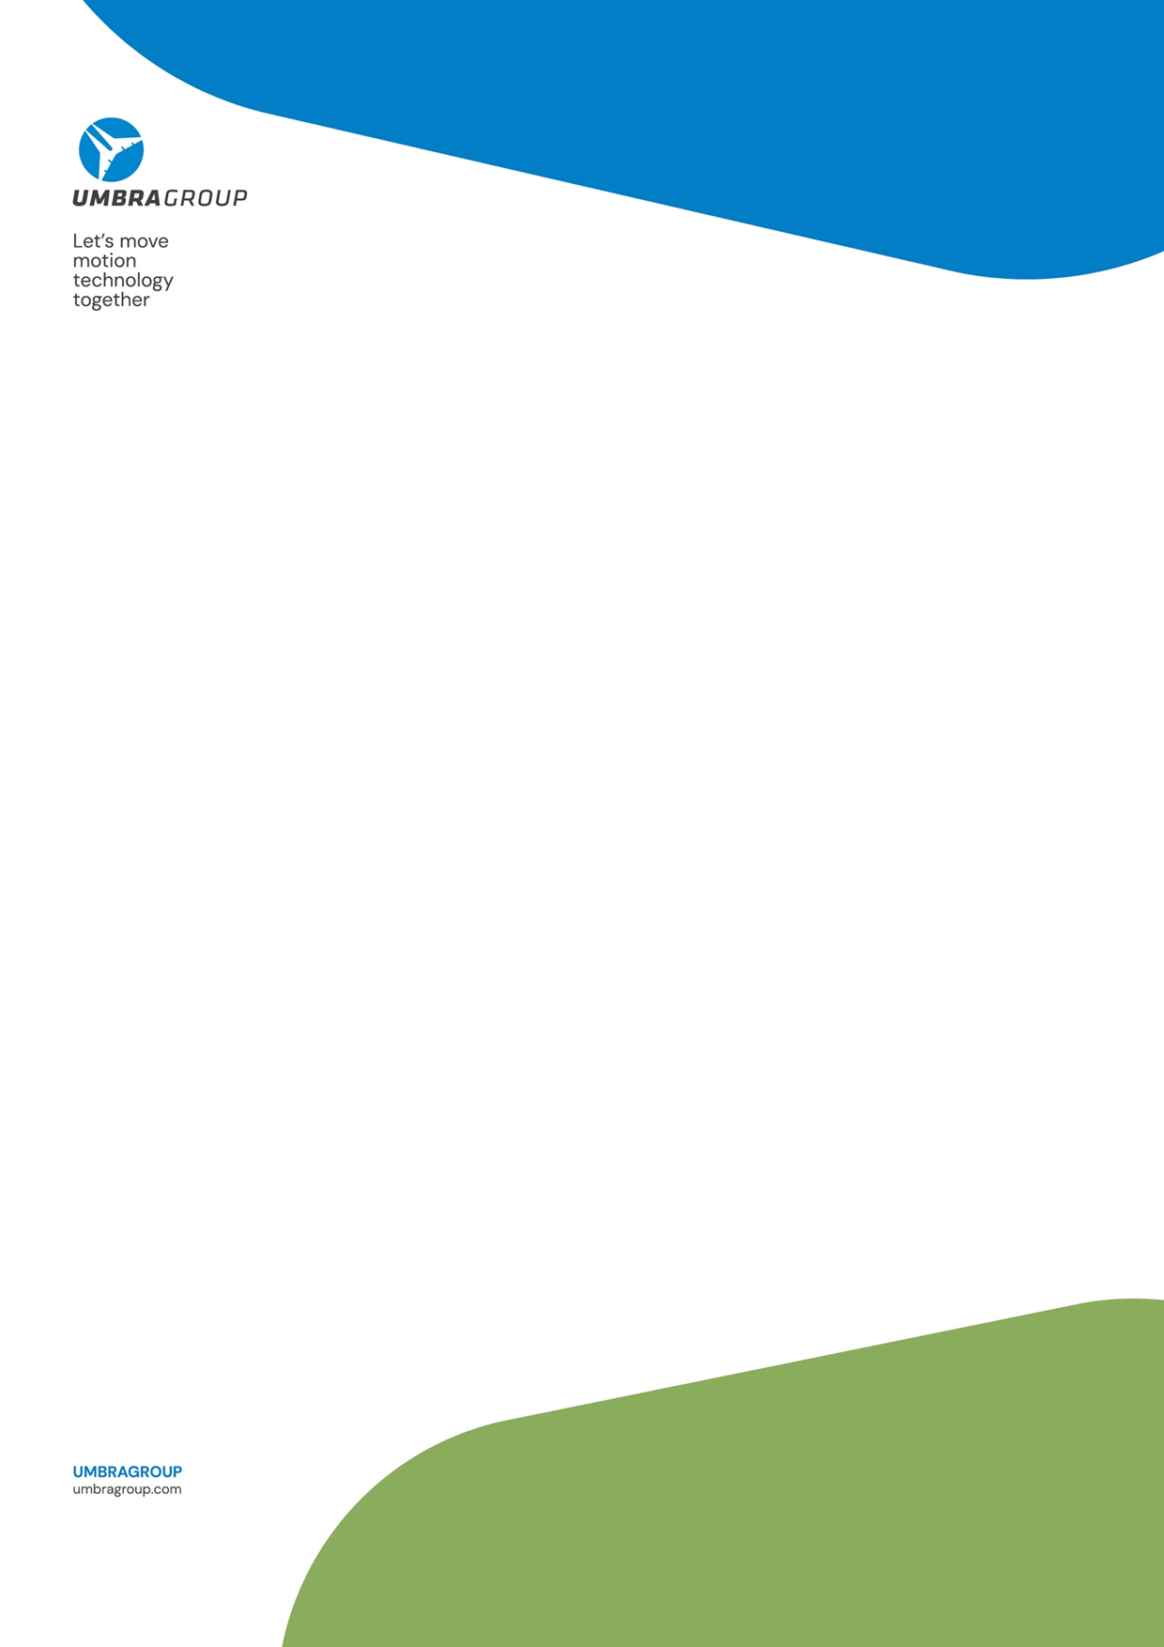
Cultivating a future of Excellence and Sustainability in service of People

It represents a golden page in UmbraGroup’s corporate history. A global leader in the production of ball screws for the aeronautical sector and one of the main players in the industrial market, UmbraGroup delivers high-performance, durable, and highly technological solutions.
The Top Employers Program has been active for over 30 years and currently certifies more than 2,230 companies in 121 countries. The certification is awarded by the Top Employers Institute to companies that meet and exceed the high standards required by the HR Best Practices Survey.
This recognition not only celebrates excellence in human resources management, but also symbolizes the company’s commitment to cultivating a stimulating, highly respectful work environment rich in opportunities for all employees. Being certified as a Top Employer means receiving a seal of approval that confirms the company’s position of excellence within the national professional landscape.
Employees are placed at the center of the corporate model, guided by long-standing values summarized in the FIRST acronym: Focus on the Customer, Innovation, Respect, Social Development, Teamwork (Together for one goal).
Above all, FIRST represents the human touch and sense of care experienced by all UmbraGroup stakeholders: employees, customers, suppliers, and the broader community.
CERTIFICATION
Achieving the certification is also an opportunity to highlight the services and benefits offered, which are fundamental to employees’ professional, personal, and social well-being. A distinctive feature is the strong focus on health and personal care.
This commitment is reflected in the presence of a dedicated company restaurant, where employees are served balanced meals, with costs borne almost entirely by the company. UmbraGroup also provides supplementary healthcare insurance, covering both employees and their dependent family members.
Through the MAP Project (Movement, Nutrition, Posture) – The Path to Well-Being, employees can benefit from nutritional consultations and personal training sessions, held directly at company facilities.
it has adopted remote working and flexible working hours—an increasingly valued approach in a society where both parents often work and daily rhythms are particularly fast-paced.
To strengthen employees’ sense of belonging, UmbraGroup rewards seniority by providing a welfare bonus ranging from €400 to €3,000, depending on years of service, to those who have contributed to the company’s success over time.

UMBRAGROUP: PROUDLY, TODAY THE COMPANY ANNOUNCES THE ACHIEVEMENT OF THE PRESTIGIOUS TOP EMPLOYER 2025 CERTIFICATION

The project is further enhanced by a public green fitness area located opposite the company headquarters, available free of charge both to UmbraGroup employees and to the local community.
UmbraGroup firmly believes in work–life balance, which is why it has adopted remote working and flexible working hours—an increasingly valued approach in a society where both parents often work and daily rhythms are particularly fast-paced.
To strengthen employees’ sense of belonging, UmbraGroup rewards seniority by providing a welfare bonus ranging from €400 to €3,000, depending on years of service, to those who have contributed to the company’s success over time.
Lifelong learning is another key priority, demonstrated through continuous investment in managerial and technical training, as well as partnerships with leading industry players. Employees acquire new skills and further develop existing ones in an ever-evolving world, supported by the conviction that one of a company’s greatest responsibilities is to promote continuous learning and individual fulfillment.
UmbraGroup is also the first company to join the “Azienda Giusta” membership program, promoted by the Valter Baldaccini Foundation. The initiative is dedicated to companies and small businesses that wish to provide tangible support through donations to people facing hardship. The program aims to serve the common good, assisting families, young people in difficulty, women, and single mothers seeking new opportunities in Umbria, across Italy, and worldwide.
For UmbraGroup, becoming an Azienda Giusta is a heartfelt commitment rooted in the legacy of Valter Baldaccini, founder of the Foligno-based multinational, who made corporate social responsibility a cornerstone of his managerial philosophy.
Particular attention is also devoted to gender diversity, clearly reflected in the significant growth in female hiring. Data shared on March 8, 2024, on the occasion of International Women’s Day, highlighted a 50% increase in female recruitment over the past 36 months, with 20 new women hired, 18 of whom hold degrees in scientific disciplines. This commitment is further confirmed by the renewed Board of Directors of UmbraGroup SpA, now comprising over 30% female representation.
“Behind a TOP company are TOP people who drive its growth.
We celebrate all those who, with passion and dedication, make UmbraGroup a successful company—building a better tomorrow for future generations.”
UmbraGroup has developed its own leadership model known as “SAFETY: Work Together, Win Together.” The primary goal is to foster a culture of widespread psychological safety, where individuals feel free to express ideas—creating the conditions from which true product and process innovation can emerge. The model was designed through active listening to stakeholders and focus groups involving managers from subsidiaries, ensuring an inclusive and international perspective.

Sustainability plays a central role at UmbraGroup, which makes significant investments in:
- Monitoring and reducing water consumption, with wastewater reuse for internal purposes
- Reducing waste generated per unit of product
- Increasing the use of renewable energy through self-consumption photovoltaic systems
Sustainable mobility is also promoted through initiatives encouraging employees to reduce the environmental impact of commuting. Through the Wecity app, employees accumulate saved CO₂ points, later converted into rewards. In addition, a significant share of the company fleet consists of hybrid and electric vehicles.
In terms of biodiversity protection, UmbraGroup participates in the “Pollinate the Planet” project, promoted by partner 3Bee, which enables the adoption of a beehive equipped with an innovative remote-monitoring system.
Finally, corporate volunteering is actively encouraged: employees are given the opportunity, during working hours, to support local associations committed to environmental protection and community well-being, with particular attention to the most vulnerable segments of society.

